Preparation of your Abstract for ISAR-9

K. Yokosuka^{1*§}, H. Sapporo², and T. Tachikawa³

¹Japan Agency for Marine-Earth Science and Technology, Japan
²Hokkaido University, Japan
³National Institute of Polar Research, Japan
§Corresponding author: assw2027@jamstec.go.jp
A one-page abstract should be prepared in the following format: (1) Use a sheet of A4 size paper. (2) Start the first line leaving the space of 2.5 cm on the upper side. (3) Title of the paper (Arial type 16 points, bold, first letters caps, centered) could span in maximum three rows, and is followed by one blank line. (4) Author’s names are written (Times New Roman type, 12 points, centered) with the order of first name and family names, followed by one blank line. Authors are separated by commas and marked with superscript when necessary to distinguish authors from different affiliations. The presenting author’s name should be marked with *, and the corresponding author’s name should be marked with §. (5) Author’s affiliations (Times New Roman type, 12 points, italic, centered) are written in separate rows. (6) The corresponding author’s email address is written below the affiliations (Times New Roman type, 12 points, italic, centered). (7) Insert one blank line between the affiliations and the main text. (8) Use 12 points and Times New Roman type for the main text and smaller fonts may be used for figure captions. (9) Leave the space of 2.5 cm on the both side of the text. (10) Main text should be fully justified with five spacing. (11) Leave the space of 2.5 cm at least on the bottom of the text, since the page number will be printed there. (12) References should be indicated in the text in square brackets, such as [1] and listed at the end of the paper (11 points). (13) Figures should be high quality graphics, line drawings, or black and white photographs, and placed preceding the reference list. (14) Acknowledgement may be addressed as a last paragraph of the text body. (15) Please upload this abstract as a PDF file. (16) All abstracts accepted for the symposium will be available at the ISAR-9 website, and the title and authors will be listed in the symposium program.
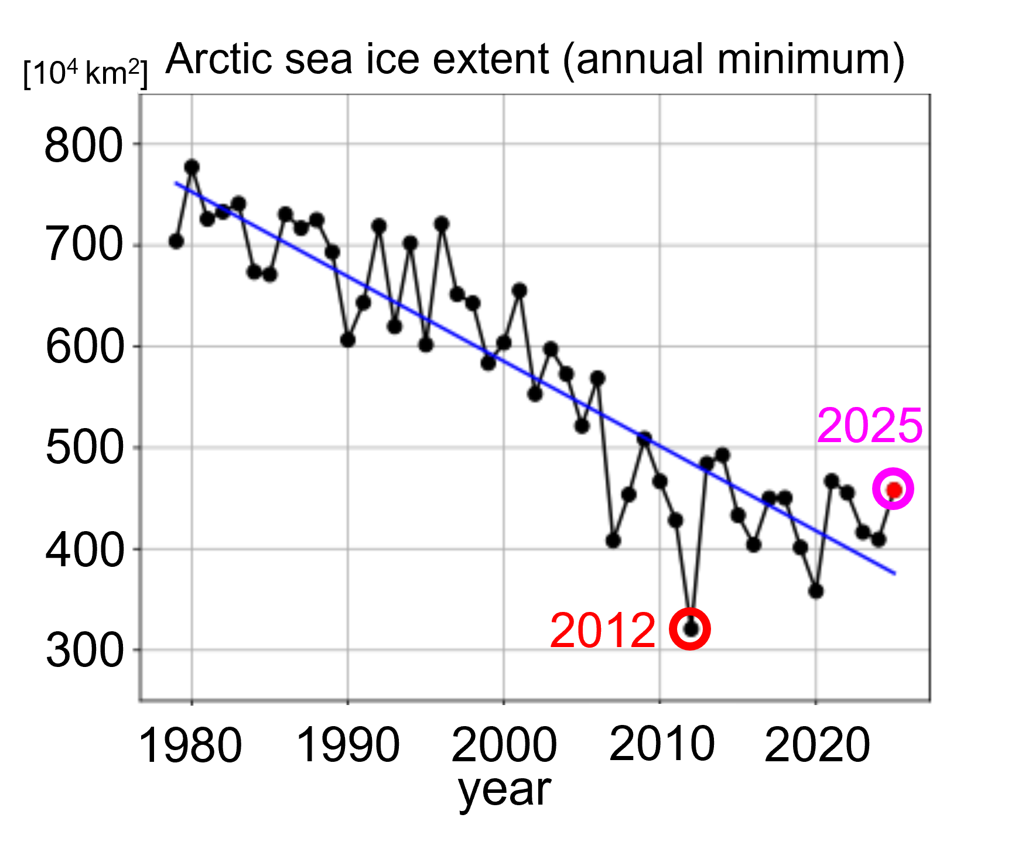
Figure 1. Arctic sea ice extent (annual minimum) [https://ads.nipr.ac.jp/vishop/#/extent]

Reference
[1] M. Ikeda (2025). Arctic Challenge for Sustainability II (ArCS II) project. Polar Science, 45, 101268. https://doi.org/10.1016/j.polar.2025.101268

